# INTRODUCTION

* 1. Overview

Our Topic is India’s Agricultural Crop Production Analysis (1997-2021). We analyze the given Data set and create sheet, dashboard and story in tableau according to our topic.

* 1. Purpose

Agriculture is the main source of livelihood and income for more than 70% of the population of India. So we can analyze this project to increase the production in the next year to satisfy our needs.

1. **Problem Definition & Design Thinking**
   1. Empathy Map

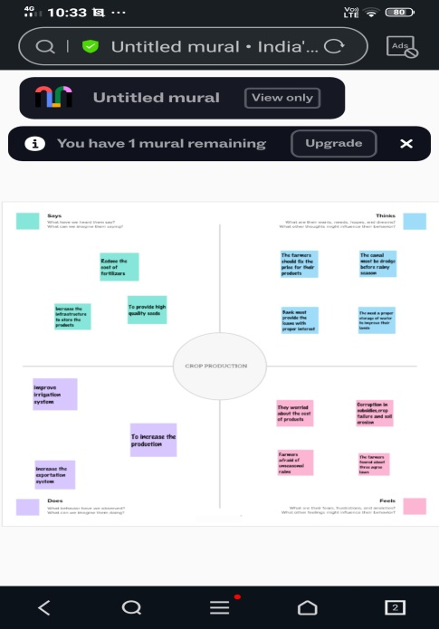

* 1. Ideation & Brainstorming Map

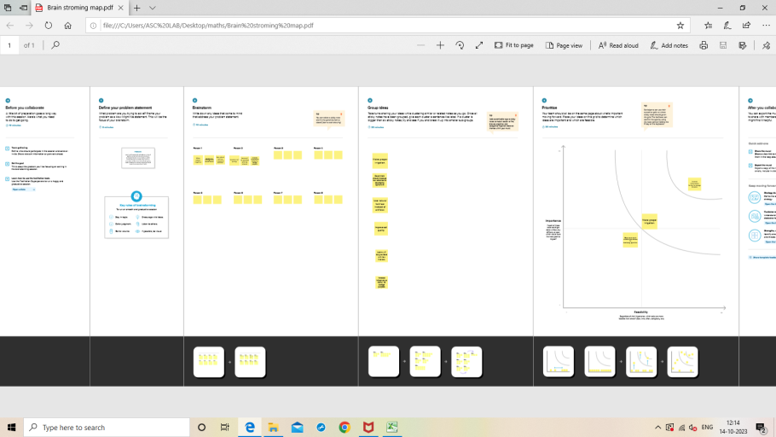

# C:\Users\ASC LAB\Desktop\New folder\Screenshot 2023-10-14 123003.pngC:\Users\ASC LAB\Desktop\New folder\Screenshot 2023-10-14 123217.png3 RESULT

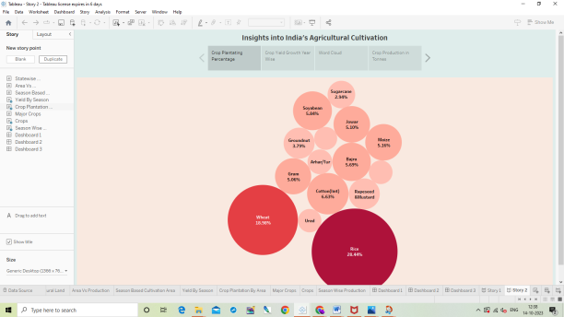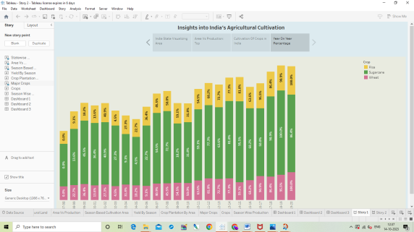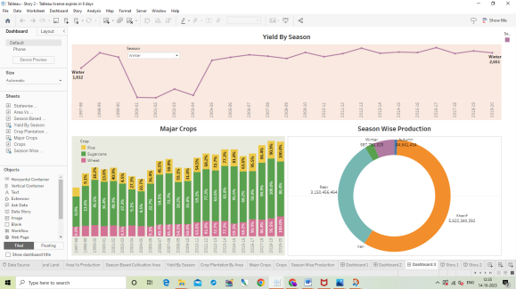

# 4 ADVANTAGES & DISADVANTAGES

Advantages

* The yield in winter is increased from the year 1997-2020.
* The production of the rice more than the other crops.

Disadvantages

* The production of millets is very low.
* The production in autumn season is lower than other season.

# APPLICATIONS

The millets can be grown in mountain areas.

# CONCLUSION

We create empathy map and brainstorming map then we connect data set with tableau. We create sheets, dashboard and story.

# FUTURE SCOPE

Due to globalization ,increase in household incomes and health consciousness the demand for fruits and vegetables ,dairy products ,fish and meat is going to increase in future.